Internship Project Report
Project Title: Intelligent Query Assistance
Submitted in partial fulfilment of the requirements for the
Google Cloud Generative AI
conducted by

SmartBridge

Submitted by
Team Leader: Uppuluri Yuva Madhuri

Team member: Jessy Rishitha Kollabathula

Team member: Jahnavi Senagana

Team member: Javvadi Rama Siva Naga Venkata Kishore

Team ID: LTVIP2026TMIDS86677
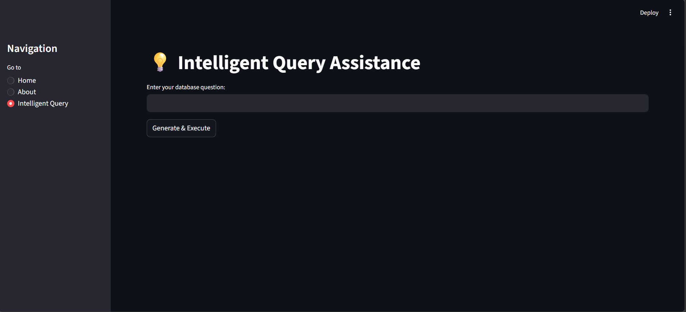

1.INTRODUCTION

1.1 Project Overview
Intelligent Query Assistance is an AI-powered web application designed to convert natural language questions into structured SQL queries and retrieve accurate database results automatically.
The system allows users to ask database-related questions in simple English, and the application intelligently generates corresponding SQL queries, executes them on a database, and displays the results in a structured format.
This eliminates the need for users to have prior knowledge of SQL syntax and database querying techniques.

1.2 Purpose
- The purpose of Intelligent Query Assistance is to simplify database interaction by enabling users to communicate with databases using natural language.

Main Purposes
• Reduce dependency on SQL knowledge
• Provide user-friendly data retrieval
• Automate SQL query generation
• Improve efficiency in database operations
• Demonstrate practical AI integration.

2. IDEATION PHASE
2.1 Problem Statement
Many users struggle with writing SQL queries to retrieve information from databases. Writing correct SQL requires technical expertise, knowledge of schema, and understanding of syntax rules.
This project aims to bridge the gap between non-technical users and databases by providing an intelligent system that converts natural language into executable SQL queries.
2.2 Target Users:
- Students learning databases
- Non-technical employees
- Data analysts
- Developers
- Educators
2.3 Brainstorming
Core Features
- Natural Language Input
- Automatic SQL Query Generation
- Query Execution on Database
- Structured Output Display
- Error Handling, Simple and Interactive UI

3. REQUIREMENT ANALYSIS
3.1 Functional Requirements
1. Natural Language Input
The system must allow users to enter queries in simple English through a user-friendly interface.
2. Query Understanding
The system should analyze the input text, identify keywords such as table names, column names, and conditions, and determine the user’s intent.
3. SQL Query Generation
The application must convert the natural language input into a syntactically correct SQL query based on predefined rules or logic.
4. Database Execution
The generated SQL query must be executed on the connected SQLite database.
5. Result Display
The system should display query results in a structured table format within the web interface.
6. Error Handling
If the input is invalid or cannot be converted into SQL, the system must display an appropriate error message instead of crashing.
7. Session Handling
The system should allow multiple queries in a session without restarting the application

3.2 Non-Functional Requirements
1. Performance
The system should generate and execute queries within a few seconds to ensure smooth user experience.
2. Usability
The interface must be simple and intuitive so that even non-technical users can operate it without guidance.
3. Reliability
The application should consistently generate correct SQL for supported query types.
4. Security
Sensitive information such as API keys (if used) must be stored securely using environment variables.
5. Scalability
The system should be designed in a way that future improvements (like adding LLM integration or multi-table support) can be implemented easily.
6. Portability
The application should run on different systems without complex configuration

3.3 System Constraints
- The system currently supports only predefined database schema.
- Complex joins and nested queries may not be fully supported.
- Accuracy depends on rule-based logic.
3.3 Data Flow Diagram
User Input → NL Processing → SQL Query Generation → Database Execution → Output Display

3.4 Technology Stack
Programming Language – Python
Python is used to implement the core backend logic, including natural language processing and SQL query generation. Its simplicity and strong library support make it suitable for rapid development and database integration
Web Framework – Streamlit
Streamlit is used to design the interactive web interface where users input queries and view results. It enables quick deployment of data-driven applications without requiring frontend development knowledge.
Database – SQLite
SQLite is used as a lightweight relational database to store and manage structured data for query execution. It provides efficient local database operations without requiring a separate server setup.
Version Control – Git & GitHub
Git is used to track code changes and manage version history during development. GitHub serves as a remote repository for collaboration, backup, and project submission.
Environment Management – python-dotenv
python-dotenv is used to securely manage environment variables such as configuration settings. It prevents sensitive data from being hardcoded into the source code
Virtual Environment – venv
A Python virtual environment is used to isolate project dependencies and maintain consistent package versions across different systems

4. PROJECT DESIGN
4.1 Proposed Solution
Develop a rule-based intelligent query engine that:
• Accepts user input in English
• Identifies intent and keywords
• Converts input into SQL query
• Executes query on SQLite database
• Displays formatted results
4.2 Solution Architecture

User Interface (Streamlit)
↓
Query Processing Engine
↓
SQL Query Generator
↓
SQLite Database
↓
Result Display
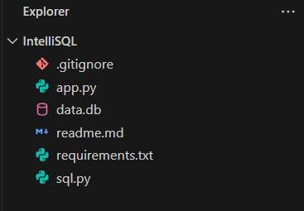

5. PROJECT PLANNING & SCHEDULING

5.1 Project Planning
Ideation – 1 Week
In this phase, the concept of Intelligent Query Assistance was defined. The problem statement, objectives, system workflow, and feature requirements were identified and finalized.

Development – 2 Weeks
During this phase, the application was built using Python, Streamlit, and SQLite. The rule-based query engine was implemented to convert natural language into SQL queries and execute them.

Testing – 1 Week
The system was tested with multiple user inputs to verify SQL generation accuracy, output correctness, and error handling. Edge cases and invalid queries were also checked.

Documentation – 1 Week
In this phase, the complete project report was prepared, including system architecture, requirement analysis, screenshots, and technical explanations.

6. FUNCTIONAL AND PERFORMANCE TESTING
6.1 Functional Testing:
Test Case 1: Show all records
Input: Show all records
Generated SQL Query:
SELECT * FROM students;
Result:
The system successfully converted the natural language query into a valid SQL statement and retrieved all records from the students table. The output was displayed in a structured tabular format without any errors

Test Case 2: Conditional Query
Input: Show students with marks greater than 80
Generated SQL Query:
SELECT * FROM students WHERE marks > 80;
Result:
The system successfully identified the filtering condition from the natural language input and generated a correct SQL query with a WHERE clause. The database returned only the records that satisfy the condition (marks greater than 80), and the filtered results were displayed in a structured tabular format without errors.
Test Case 3: Invalid / Unsupported Query
Input: Delete all student records
Generated SQL Query:
No query generated
Result:
The system identified that the request is unsupported and restricted. Since the application is designed to allow only SELECT operations, it did not generate any SQL query. Instead, a meaningful error message was displayed to the user, ensuring database safety and preventing unintended data modification.
6.2 Performance Testing
• The system generates SQL queries within seconds.
• Database execution is fast due to lightweight SQLite usage
• The application runs smoothly without performance lag.
• The system maintains stability during multiple consecutive queries.
App.py Code:
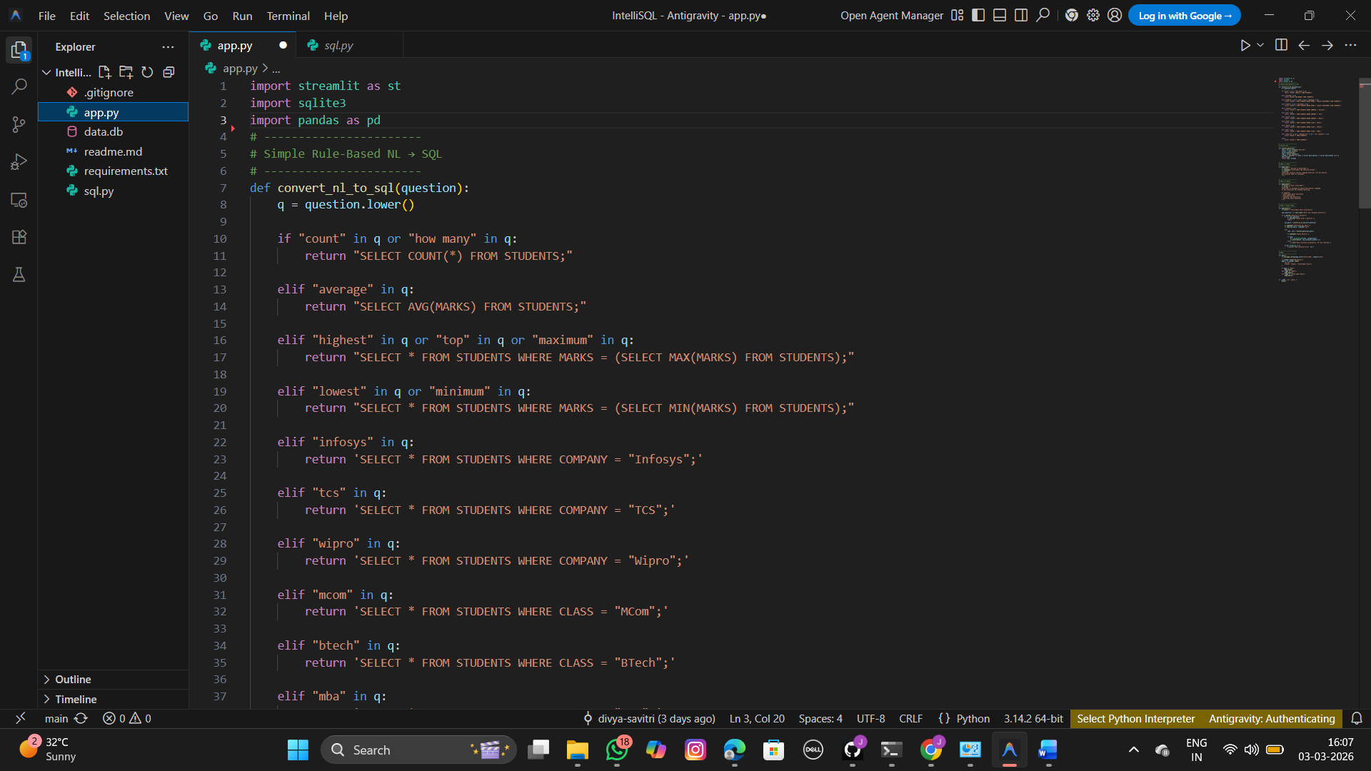
Sql.py:
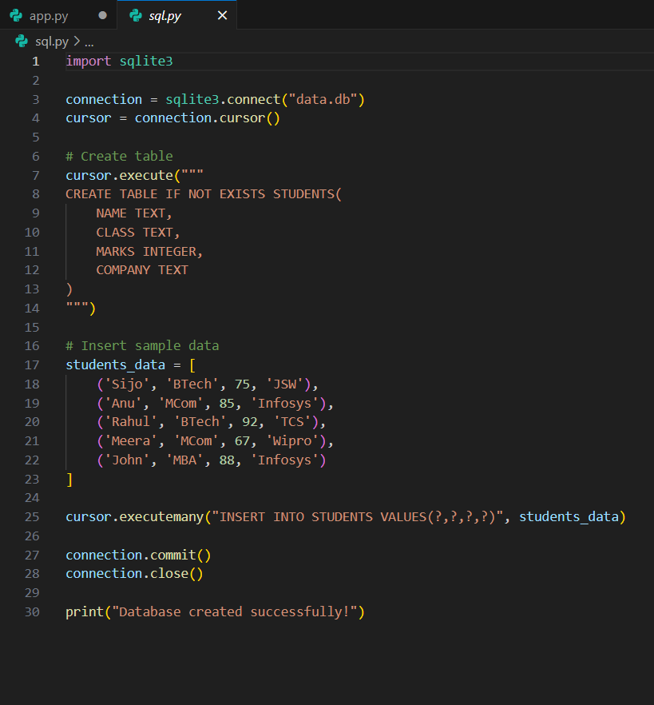
Requirements.txt:
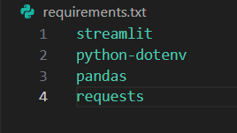
Running the Application:
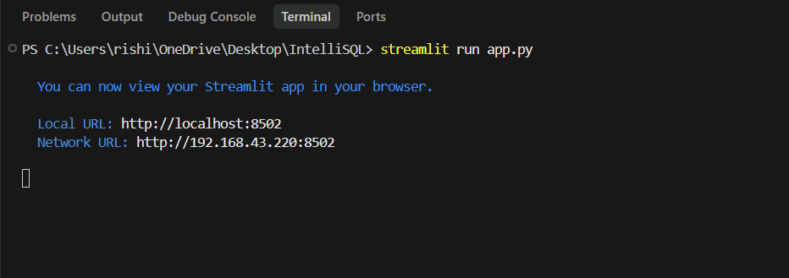

7. RESULTS
7.1 User Interface Screenshots
Home Page -
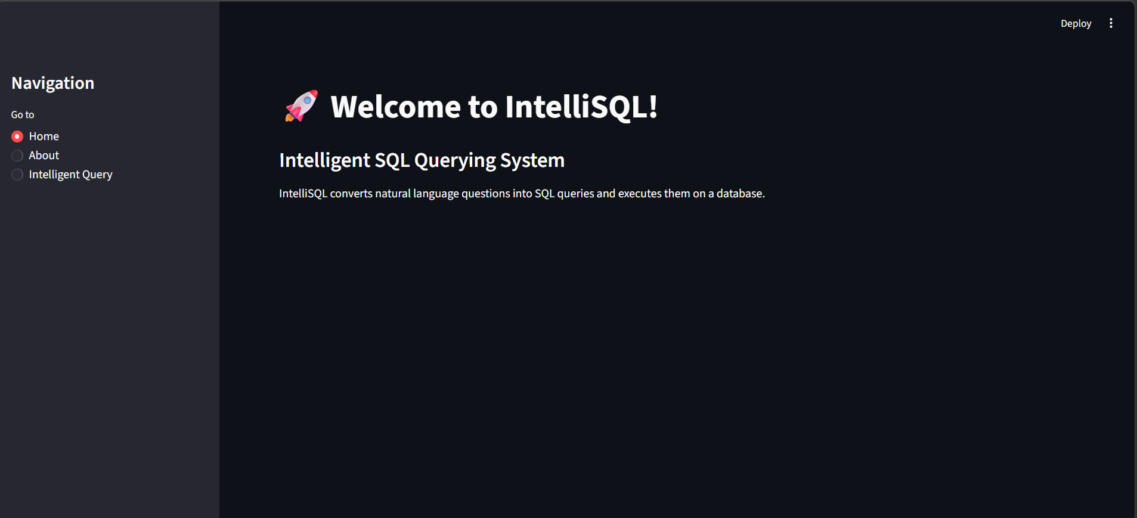
Brief explanation:
The home page provides navigation and basic project overview.
About Page -
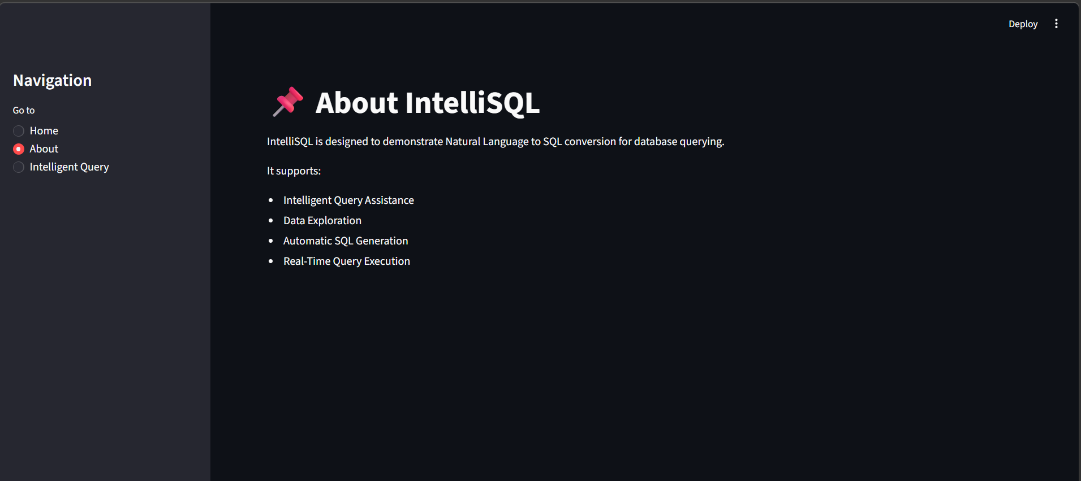
Brief explanation:
The about page explains the purpose and functionality of the system.
Intelligent Query Page –

Brief explanation:
This page allows users to enter natural language queries, view generated SQL statements, and see database results.
7.2 Output
The application successfully converts natural language queries into SQL and retrieves accurate results from the database.
Example 1:
User Input:
Show all students
Generated SQL:
SELECT * FROM students;
Output:
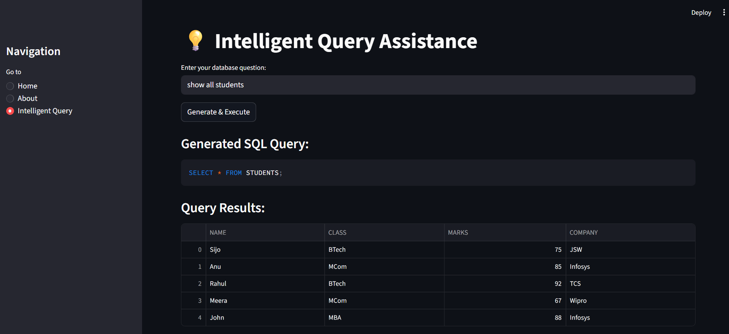
Example 2:
User Input: Displaying records of student working at INFOSYS
Generated SQL:
SELECT * FROM STUDENTS WHERE MARKS = (SELECT MAX(MARKS) FROM STUDENTS);
Output:
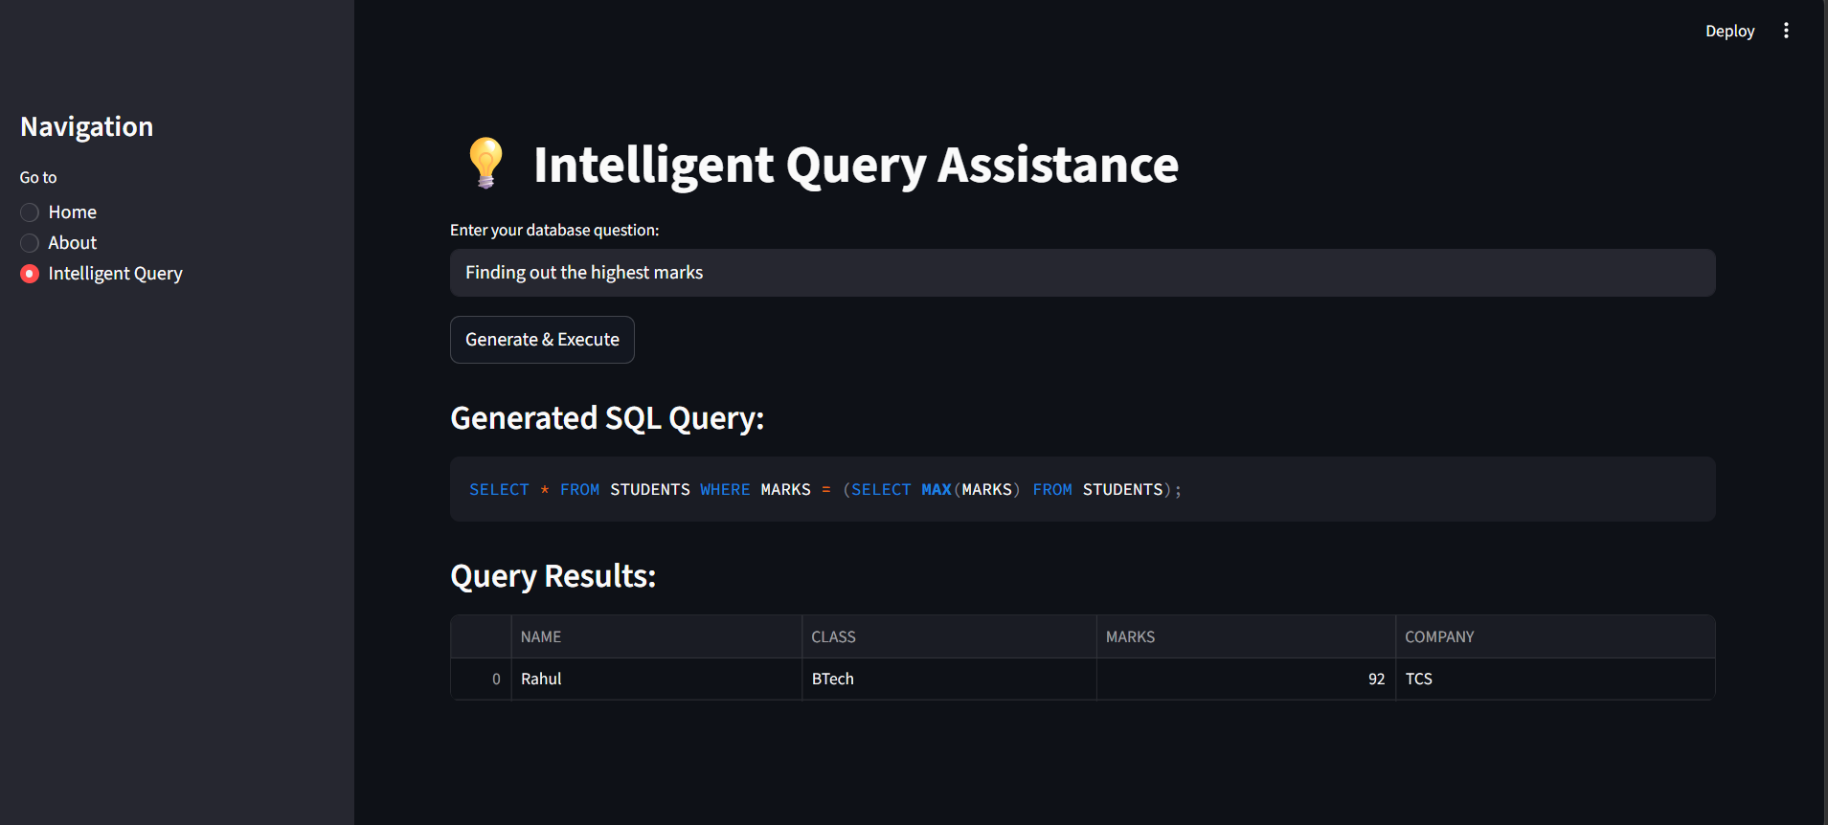

8. ADVANTAGES & DISADVANTAGES
Advantages
1️⃣ No SQL knowledge required
2️⃣ Easy to Use
3️⃣ Fast query execution
4️⃣ Lightweight and Easyto deploy
5️⃣ Beginner-friendly Database Interaction
6️⃣ Encourages Digital Transformation

Disadvantages
1️⃣ Limited to predefined database schema
2️⃣ Complex joins and nested queries not supported
3️⃣ Supports only basic SQL operations
4️⃣ Accuracy depends on rule-based logic

9. CONCLUSION

The Intelligent Query Assistance project was developed to make database interaction easier for users who do not know SQL. Many people find it difficult to write structured queries to retrieve data from databases. This project solves that problem by allowing users to type their questions in simple English, and the system automatically converts those questions into SQL queries. The generated query is then executed on the database, and the results are displayed in a clear tabular format.
During the development of this project, a rule-based approach was used to identify keywords and conditions from the user’s input. Based on these identified patterns, the system generates the appropriate SQL command. The application was built using Python, Streamlit, and SQLite, which helped create a simple and interactive web interface. The system works efficiently for basic SELECT queries and simple filtering conditions, making it useful for beginners and non-technical users.
Although the system currently supports only predefined database structures and limited operations, it successfully demonstrates how natural language can be used to simplify technical processes like database querying. Error handling is also included to manage unsupported or incorrect inputs, ensuring safe execution without affecting the database.
Overall, this project shows how logical automation can reduce complexity and improve accessibility in database systems. With future improvements such as AI-based natural language processing and support for complex queries, the Intelligent Query Assistance system can be expanded into a more advanced and practical solution for real-world applications.

10. FUTURE SCOPE
• Integration with Large Language Models (LLMs)
• Multi - database support
• Cloud deployment
• Authentication system
• Advanced query understanding
• Complex join handling

11. APPENDIX
Github Repository Link:
https://github.com/Jessy-kollabathula/IntelliSQL
Demo Video Link:
https://drive.google.com/drive/folders/1m_vXdKkujfkVq1x57h6bZ3Kj_07hdh4T?usp=sharing

